

**Sukkur Institute of Business Administration University**

Department of Electrical Engineering

**Casino Number Guessing Game**

Group Members:

1. Ukasha Abdul Majeed

2. Arslan Aslam

Instructor: Engr. Aizaz Ali Larik

Lab Engineer (Electrical Engineering)

**Table of Contents**

| **Sr. No#** | **Topic** | **Page. #NO.** |
| --- | --- | --- |
| 1. | Certificate | 2 |
| 2. | Certificate | 3 |
| 3. | Introduction | 4 |
| 4. | Working Principle | 4 |
| 5. | Flow chart | 5, 6 |
| 6. | Output | 7 |
| 7. | Code | 8, 9, 10 |

Certificate

*It is certified that* ***Mr****.* ***Ukasha Abdul Majeed*** *having* ***CMS ID 031-21-0006*** *a student of* ***BE-II*** *has carried out the “****Semester Project****” for the subject of* ***Programming for Engineers (PfE)*** *as provided by the Instructor of the subject at the department of Electrical Engineering, Sukkur Institute of Business Administration for* ***Fall-2021.***

Date: _______________ Instructor’s Signature

Certificate

*It is certified that* ***Mr. Arslan Aslam*** *having* ***CMS ID 031-21-0002*** *a student of* ***BE-II*** *has carried out the “****Semester Project****” for the subject of* ***Programming for Engineers (PfE)*** *as provided by the Instructor of the subject at the department of Electrical Engineering, Sukkur Institute of Business Administration for* ***Fall-2021.***

Date: _______________ Instructor’s Signature

**Introduction:**

Casino Game is a game in which a bid on a number and if that number wins. He/she will win more than his/her bidding amount and if he/she lost than their amount will become will zero.

**Working Principle:**

* First it will ask you to enter your name.
* Than after successfully writing your name program will ask you to write your balance or money which you have.
* Than program will ask you that are you sure you want to play. You have to answer as yes or no.
* Than it will ask you that how much amount you want to bid from your balance.
* After you successfully put bidding amount. Program will ask you that on which number you want to bid on.
* So now it will depend on your luck. If the winning number and your bidding number is same than you will get 5 times of your bidding amount.
* If winning number and your bidding number is not same than bided amount will be deducted from your balance.
* After this program will ask you again that whether you want to play game or not. If you will say yes than it will run again and if you will say no than program will exit and will refund your remaining balance.

**Flow Chart:**













































































**Output:**

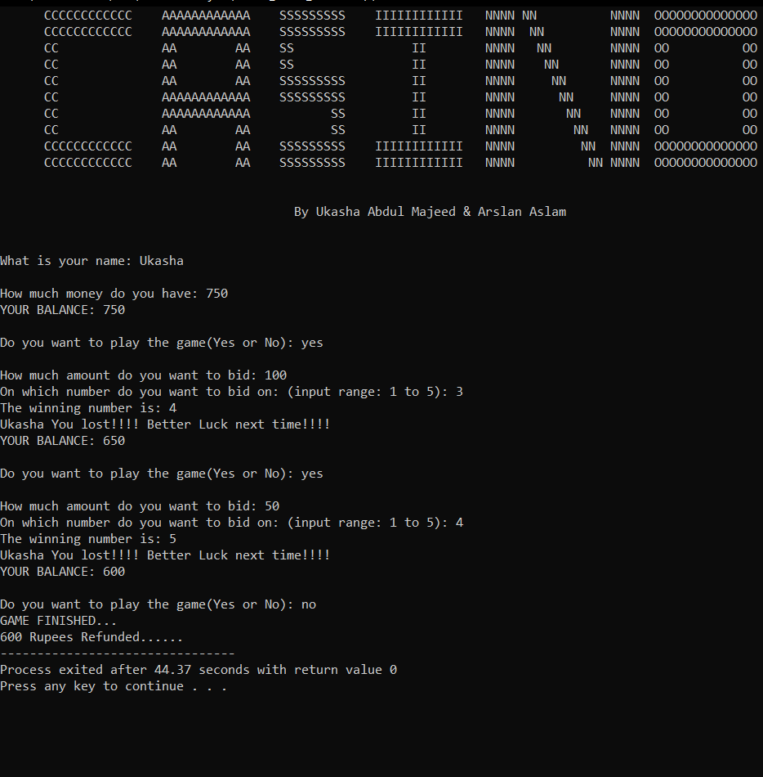

**Code:**

#include<iostream>

#include<cstring>

#include<cstdlib>

#include<ctime>

using namespace std;

int main(){

cout<<" CCCCCCCCCCCC AAAAAAAAAAAA SSSSSSSSS IIIIIIIIIIII NNNN NN NNNN OOOOOOOOOOOOOO"<<endl;

cout<<" CCCCCCCCCCCC AAAAAAAAAAAA SSSSSSSSS IIIIIIIIIIII NNNN NN NNNN OOOOOOOOOOOOOO"<<endl;

cout<<" CC AA AA SS II NNNN NN NNNN OO OO"<<endl;

cout<<" CC AA AA SS II NNNN NN NNNN OO OO"<<endl;

cout<<" CC AA AA SSSSSSSSS II NNNN NN NNNN OO OO"<<endl;

cout<<" CC AAAAAAAAAAAA SSSSSSSSS II NNNN NN NNNN OO OO"<<endl;

cout<<" CC AAAAAAAAAAAA SS II NNNN NN NNNN OO OO"<<endl;

cout<<" CC AA AA SS II NNNN NN NNNN OO OO"<<endl;

cout<<" CCCCCCCCCCCC AA AA SSSSSSSSS IIIIIIIIIIII NNNN NN NNNN OOOOOOOOOOOOOO"<<endl;

cout<<" CCCCCCCCCCCC AA AA SSSSSSSSS IIIIIIIIIIII NNNN NN NNNN OOOOOOOOOOOOOO"<<endl<<endl<<endl;

cout<<" By Ukasha Abdul Majeed & Arslan Aslam"<<endl<<endl<<endl;

cout<<"What is your name: ";

string name;

cin>>name;

cout << "\nHow much money do you have: ";

int balance;

cin >> balance;

while(true){

if(balance <= 0){

cout << "You ran out of money.";

break;

}

cout << "YOUR BALANCE: " << balance << endl;

cout << "\nDo you want to play the game(Yes or No): ";

string choice;

cin>>choice;

if(choice=="yes" || choice=="YES" || choice=="Y" || choice=="y"){

cout << "\nHow much amount do you want to bid: ";

double bidAmount;

cin >> bidAmount;

if(balance<bidAmount){

cout<<"Please enter amount in balance range!!!!"<<endl;

continue;

}

cout << "On which number do you want to bid on: (input range: 1 to 5): ";

int number;

cin >> number;

srand(time(0));

int random = rand()%5+1;

cout<<"The winning number is: "<<random<<endl;

if(random == number){

balance += bidAmount*5;

cout << "Congrats!"<<name<<" You won "<<bidAmount*5<<"Rs.\n";

continue;

}

else{

balance -= bidAmount;

cout <<name<<" You lost!!!! Better Luck next time!!!!\n";

}

}

else{

cout << "GAME FINISHED..."<<endl;

if(balance>0){

cout<<balance<<" Rupees Refunded......";

}

break;

}

}

return 0;

}